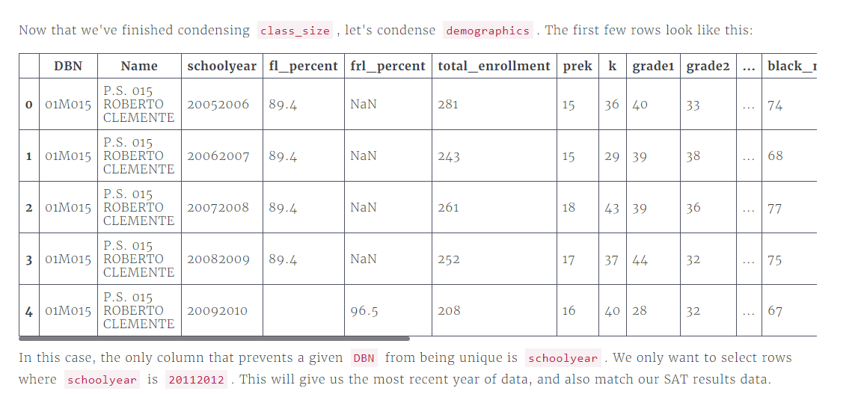

Instructions

* Filter demographics, only selecting rows in data["demographics"] where schoolyear is 20112012.
  + schoolyear is actually an integer, so be careful about how you perform your comparison.
* Display the first few rows of data["demographics"] to verify that the filtering worked.

#filters the data demographics dataframe by specific schoolyear and assigns back the result to this dataframe

data["demographics"] = data["demographics"][data["demographics"]["schoolyear"] == 20112012]

# print first few lines

print(data["demographics"].head())